**Batch: B-1 Experiment Number: 2 - Fabrication of LAN cables in Computer Networks**

**Roll Number: 16010422234 Name: Chandana Ramesh Galgali**

**Aim of the Experiment: Fabrication of LAN cables in Computer Networks**

**Program/ Steps:**

Step 1: Cut into the plastic sheath about 1 inch (2.5 cm) from the end of the cut cable. Do not

cut deep which may cause damage to the insulation of the core.

Step 2: Unwind and pair the similar colors. Pinch the wires between your fingers and

straighten them out in a sequence of color as u want to make cable (Straight cable or cross

over cable). The color order is important to get correct

Step 3: A straight cut across the 8 wires to shorten them to 1/2 Inch (1.3 cm) from the cut

sleeve to the end of the wires by crimping tool. Carefully push all 8 unstrapped colored wires

into the connector. Plastic sleeve should be inserted properly in the connector.

Wrong way: The plastic sleeve is not inside the connector where it can be locked into place.

The wires are too long. The wires should extend only 1/2 inch from the blue cut sleeve. The

wires do not go all the way to the end of the connector. The wires are too short

Step 4: Crimping the cable- Carefully place the connector into the Ethernet Crimper and

cinch down on the handles tightly. The copper splicing tabs on the connector will pierce into

each of the eight wires. There is also a locking tab that holds the plastic sleeve in place for a

tight compression fit. When you remove the cable from the crimper, that end is ready to use.

For a standard ‘straight through’ cable, repeat all steps and wire colour order on the other end

of the cable. For a crossover cable, the other end will have a different colour order as shown

by the crossover picture above.

Step 5: Test the cable- Check the continuity of connectors using ping from a computer.

**Output/Result:**

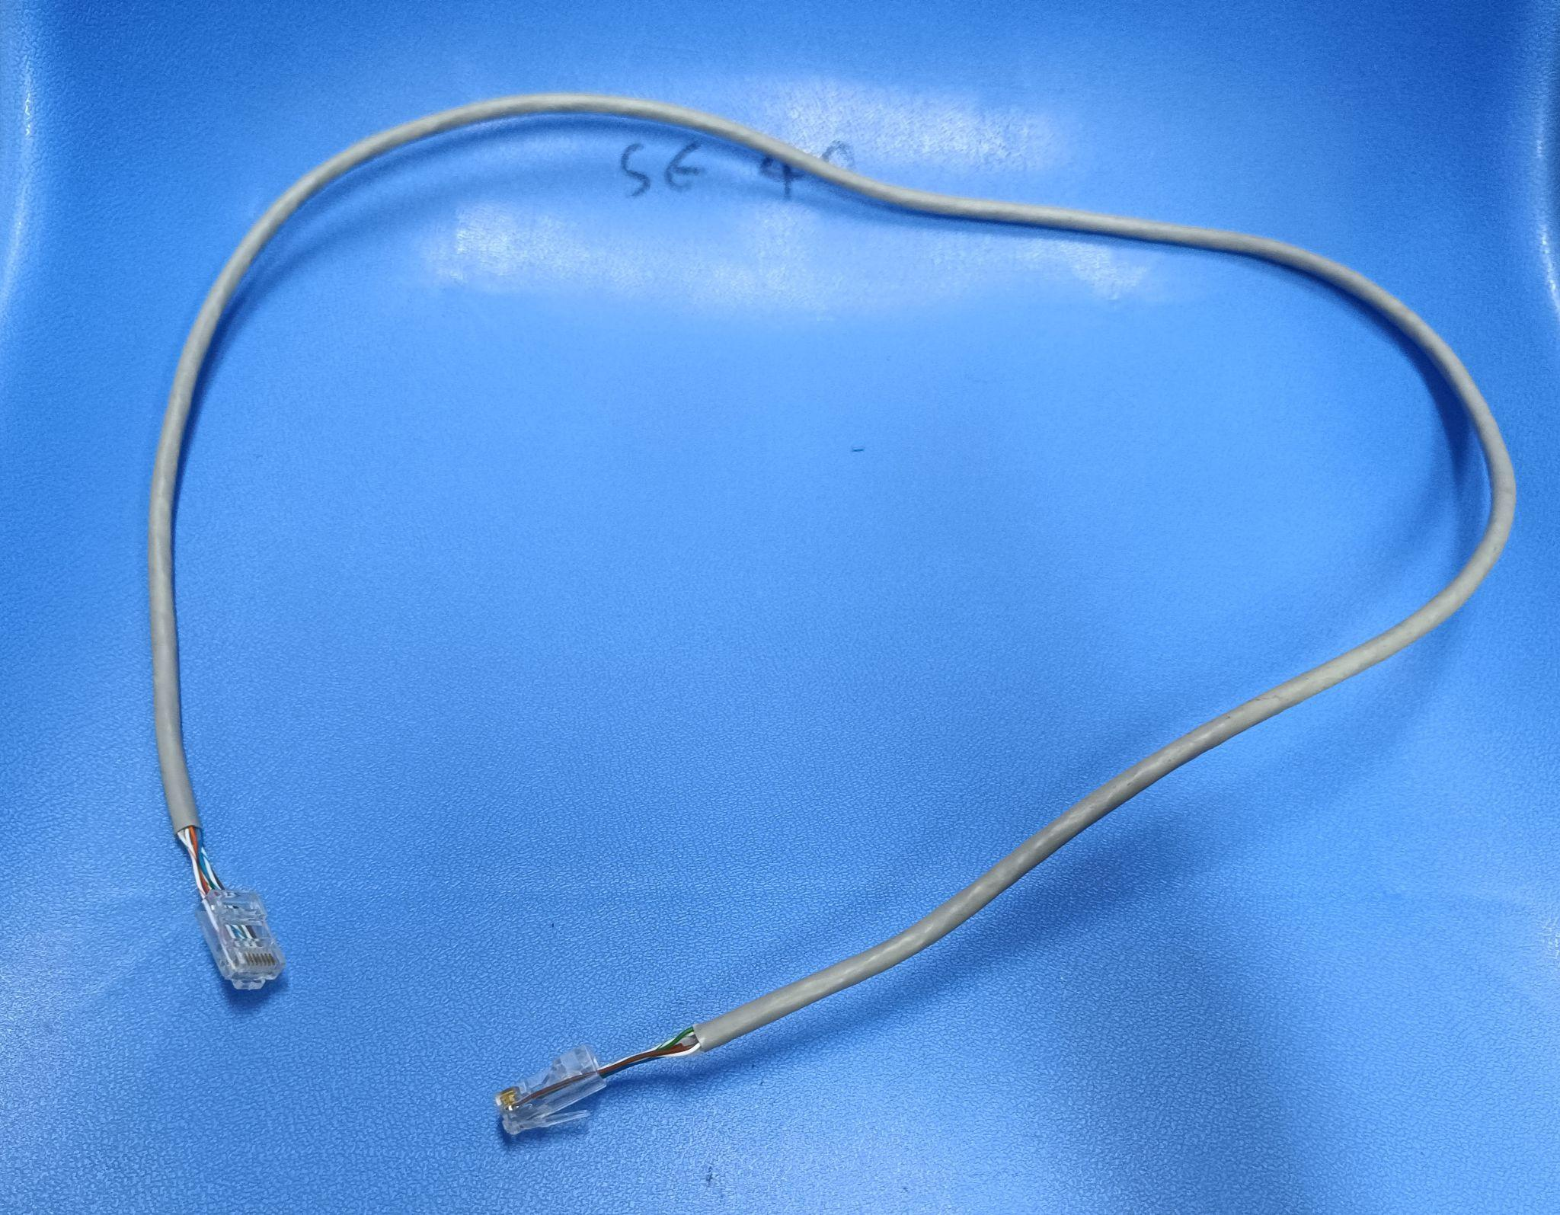

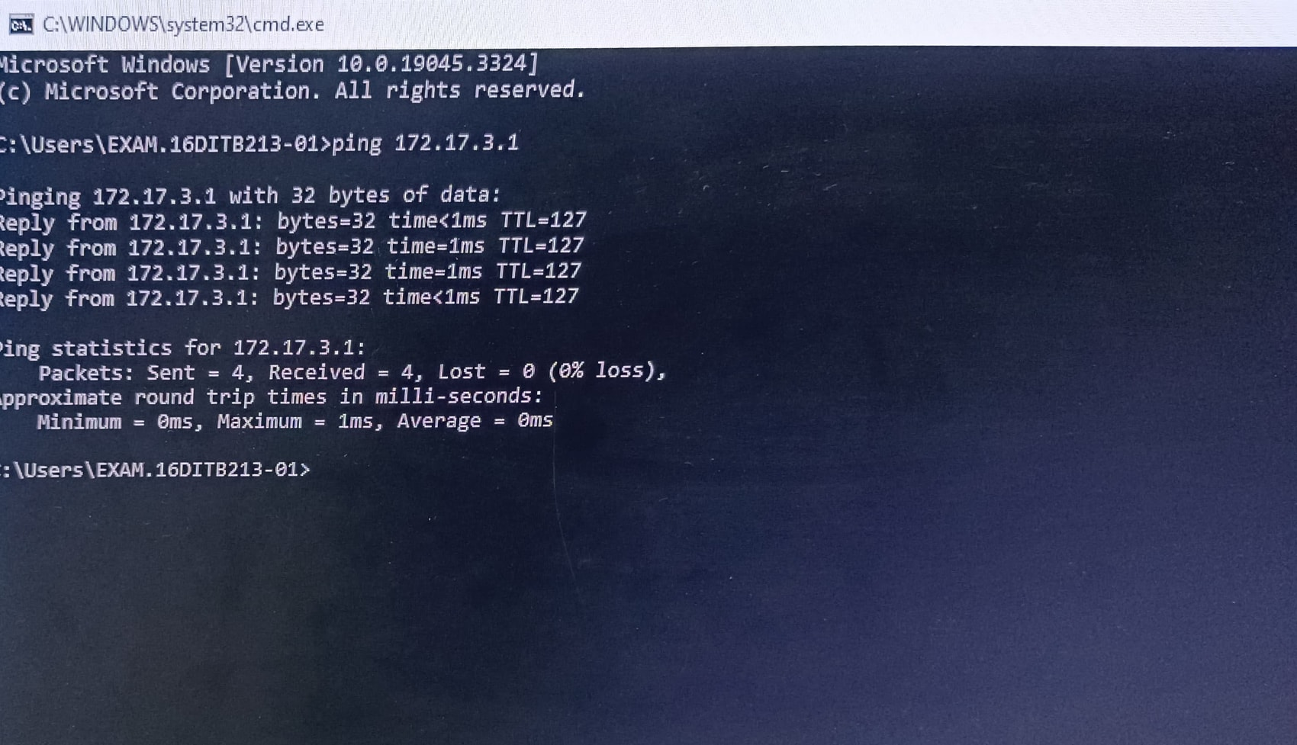

**Post Lab Question-Answers:**

**1. The slowest transmission speeds are those of**

a. Twisted-pair wire

b. Coaxial cable

c. Fibre-optic cable

d. Microwaves

**2. Compare coaxial cable and optical fibre cable.**

**Ans:** Coaxial cable and optical fiber cable are both used for transmitting data, but they differ in terms of their construction, performance, and capabilities.

Coaxial cable consists of a central conductor, surrounded by a dielectric insulating layer, a metallic shield, and an outer insulating layer. It is commonly used for cable television (CATV) and broadband internet connections. Coaxial cable is capable of carrying signals over long distances, but its bandwidth and data transmission capacity are limited compared to optical fiber.

On the other hand, optical fiber cable is made of thin strands of glass or plastic, called optical fibers, which transmit data using light signals. It is widely used in telecommunications and high-speed internet connections. Optical fiber offers several advantages over coaxial cable, including higher bandwidth, faster data transmission speeds, and immunity to electromagnetic interference. It can transmit data over much longer distances without significant signal degradation.

In terms of performance, optical fiber cable can support much higher data rates, typically in the range of gigabits or even terabits per second, while coaxial cable typically supports data rates in the range of megabits per second. Optical fiber also has a lower latency, meaning it can transmit data with minimal delay.

However, coaxial cable has its own advantages. It is generally more affordable and easier to install compared to optical fiber. Coaxial cable is also more resistant to physical damage and can be used in harsh environments.

In summary, while coaxial cable is suitable for shorter distances and lower bandwidth applications, optical fiber cable is the preferred choice for long-distance, high-speed data transmission due to its superior performance and capabilities.

**Outcomes: Understand the data communication systems, network topologies and network**

**devices**

**Conclusion (based on the Results and outcomes achieved):**

The experiment demonstrated that with proper fabrication techniques and adherence to industry standards, LAN cables can be effectively manufactured for computer networks, providing reliable and efficient data transmission. These findings contribute to the understanding and improvement of network infrastructure in computer systems.

**References:**

**Books/ Journals/ Websites:**

1. Behrouz A Forouzan, Data Communication and Networking, Tata Mc Graw hill, India, 4th Edition
2. A. S. Tanenbaum, ”Computer Networks”, 4th edition, Prentice Hall